Impact of COVID-19 on Homeless Youth - Fort Bend Family Promise Study
Isioma Chiadikaª, Paul Daniel^{b} and Timothy Daniel^{c}
(Submitted December 1, 2020)

Author Information
- Isioma Chiadika is a senior at Strake Jesuit College Preparatory in Houston, Texas.
- Paul Daniel is a junior at the Michael E. DeBakey High School for Health Professions in Houston, Texas.
- Timothy Daniel is a senior at Harvard College in Cambridge, Massachusetts.

Contents
1. Introduction
1.1 Background
1.2 Homeless Youth
1.3 Statement of the Problem
1.4 Objectives of the Study
1.5 Significance of the Study
1.6 Scope and Limitations
2. Literature Review: Understanding Homelessness
2.1 Statistics on Homelessness
2.2 Impact of homelessness on families USIC report
2.3 Hypotheses
3. Methodology and Findings
3.1 Methodology
3.2 Findings
3.2.1 Comparing results of the homeless teenagers vs non-homeless teenagers;
3.2.1.1 Demographic comparisons:
3.2.2 Impact comparisons

3.2.2.1 Relating to impact on ability to learn and do well

3.2.2.2 Future outlook comparisons

3.2.2.3 Access to COVID related resources

3.2.2.4 Mental health

4. Discussion
5. Conclusion
References
Acknowledgements

1. Introduction

1.1 Background
The Fort Bend Family Promise Program, which began in 2005, provides immediate needs for homeless families with children¹. To address issues surrounding homeless families, the program has a day center that provides access to laundry and shower facilities, computers and internet access for parents to assist with job searches along with case managers to help with individualized plans. In addition, the program secures temporary shelter for the families at different houses of worship that have volunteered to be part of the network to assist the families towards becoming independent. Through these houses of worship, the families are provided with dinner and overnight accommodations. Family Promise also ensures that children are transported to school and can participate in activities.
COVID-19 has created a global societal, economic and health impact on everyone’s daily life with extensive consequences. The National Alliance to End Homelessness reported in their 2020 Edition that it is too soon to determine the ultimate impact of COVID-19 ^{2,3}. While COVID-19 is having far-reaching effects on everyone, the impact on the homeless and in particular, homeless youth within families, is important to ensure that such vulnerable groups are provided with necessary services and assistance that may be differentiated from those who do not suffer from homelessness.

1.2 Homeless Youth

The US Department of Housing and Urban Development (HUD)⁴ groups homelessness into different categories. These include individuals or families who lack a fixed, regular, or adequate nighttime residence, or persons who are leaving a 90-day or less residence in emergency shelter or a location not designated for human habitation. Another category includes individuals at imminent risk of homelessness where an individual or a family will lose their residence within two weeks of their application for assistance and have not identified a substitute housing arrangement. Another category includes unaccompanied youth under 25 years of age, or families with children and youth. In addition, there are individuals who are fleeing from domestic violence, trafficking or other violence and have no alternative residence.

1.3 Statement of the Problem

Young adults and teens who are homeless, within their families or on their own, are affected by the COVID-19 pandemic in many different ways. With the impracticability of self-isolation, the teens may be more prone to contracting COVID-19 and other issues. The pandemic has added to the already extremely difficult living situation.

1.4 Objectives of the Study

In this report, the study aims to provide information on the following:
1. To assess the pandemic’s direct impact on an overlooked segment of society.
2. To assess changes in the needs of the homeless teens within their families under the pandemic.
3. To compare the effects of COVID-19 on homeless teens within their families to the effects of COVID-19 in non-homeless teens in nearby communities.
4. To gather information that supports planning for services needed by the targeted families.

1.5 Significance of the Study

This research is the first of its kind in Fort Bend County, Texas with Family Promise, trying to assess the needs and changes in needs in the homeless teen community in Fort Bend County, and calling for more focused research to be conducted in the same region.

1.6 Scope and Limitations

The study was conducted in the area of Fort Bend County, Texas (for the homeless teens) and surrounding nearby communities (for the non-homeless teens). The data collected should not be generalized, as similar and broader surveys are necessary to draw a general perspective on the effect of the pandemic on homeless teens. It was difficult to reach a larger study sample due to the pandemic; however, the responses obtained provide background for broader research.

2. Literature Review: Understanding Homelessness

2.1 Statistics on Homelessness
In terms of the prevalence of homelessness, in its Annual Homeless Assessment Report, the HUD reported that on a single night in January 2019, 567,715 people were experiencing homelessness in the US⁴. This is about 17 out of every 10,000 people in the US. Texas had rates of homelessness lower than the national average (14 per 10,000 for Texas). In 2019, just under 172,000 people in 54,000 families with children were experiencing homelessness and most were staying in sheltered locations (91%), as provided by the HUD report (2019)⁴.
The average size of families experiencing homelessness was 3.2 people per family. Children under the age of 18 made up 60 percent of people experiencing homelessness in families. Of the remaining 40 percent, most were 25 years of age or older (33%). Seven percent of all people in families with children were young adults between 18 and 24.
African Americans are considerably overrepresented and accounted for 52 percent of all people in families with children experiencing homelessness and 55 percent of all sheltered families (while only 13 percent of the US population). Four of every ten people experiencing homelessness were African American (40% or 225,735 people). African Americans, however, accounted for 21% of unsheltered people in families. Nearly 3 in 10 people in families with children experiencing homelessness were Hispanic/Latino (29%), considerably higher than the proportion of Hispanic/Latino individuals experiencing homelessness (19%). Almost all Hispanic/Latino families experiencing homelessness, 94%, were sheltered⁴.
About 6 in 10 people in families were female (women and girls under 18), 4 in 10 were male, and very small numbers were transgender or gender non-conforming. Women and girls made up a smaller percentage of people in families found in unsheltered locations—54% compared to 61% of those in shelter.

2.2 Impact of homelessness on families
According to the United States Interagency Council on Homelessness (USIC)^{5,6}, for most families with children who experience homelessness, a driving factor is the shortage of affordable rental housing, given their income from employment, benefits or other sources.
Homeless families are usually headed by a single woman with limited education, are typically young, and have young children. Homelessness can have a tremendous impact on children in terms of their education, health, sense of safety, and overall development. Fortunately, researchers find that children are also highly resilient and differences between children who have experienced homelessness and low-income children who have not experienced homelessness, typically diminish in the years following a homeless episode³.
When compared to low-income and homeless families, children experiencing homelessness have been shown to have higher levels of emotional and behavioral problems, have increased risk of serious health problems, are more likely to experience separations from their families, and are more likely to experience more school mobility, repeat a grade, be expelled, or drop out of school, and have lower academic performance³.
Compared to their peers, children experiencing homelessness and housing instability are more vulnerable to and experience higher rates of mental health problems, developmental delays, poor cognitive outcomes, and depression ^{5,6}.
There was a strong relationship between residential mobility and the odds for reporting negative health outcomes including depression, smoking, attempted suicide, alcoholism, and teenage pregnancy^{5,6}.
2.3 Hypotheses

The research assumes the following:

- Homeless teens within their families are more negatively affected by COVID-19 pandemic in comparison to non-homeless teens in Fort Bend County, Texas and nearby surrounding communities..
- Homeless teens within their families are more emotionally affected by COVID-19 than non-homeless teens in Fort Bend County, Texas and nearby surrounding communities.
- COVID-19 pandemic impacts the post-graduation plans of high school teenagers.
The impact expected will be greater in homeless teenagers compared to non-homeless teenagers in Fort Bend County, Texas and nearby surrounding communities.

3. Methodology and Findings

3.1 Methodology

The study was conducted within a time interval between 6/01/2020 - 8/15/2020. Homeless teenagers participated via the Fort Bend Family Promise Program described above. The sample of the study was a convenient sample due to the private use objective of the study results. Size of the sample intended was all the internal and current population of the homeless under the Fort Bend Family Promise Program. The sample of the non-homeless teenager participants were recruited by word-of-mouth. Study participants were teenagers, ages 12 - 20 years. The Family Promise homeless teenagers were given the paper survey by hand while all other non-homeless teenagers were sent electronic surveys via Google Forms. The responses of the Family Promise homeless teenagers were entered manually into Google Forms. All analyses were performed via Google Forms and Excel 2016. An aggregate score of the negative impact of COVID was calculated based on impact responses (Figures: 4,8,9,11). A 2-sample t- Test using unequal variances on the aggregate scores was performed.

3.2 Findings
3.2.1 Comparing results of the homeless teenagers versus non-homeless teenagers

3.2.1.1 Demographic comparisons:
Information will be listed as homeless teens versus non-homeless teens. Total responses obtained were 28 vs 45. 42.9% vs 57.8% of the respondents were female. Majority were 14 - 17 years old (60.8%) in the homeless group vs (71.1%) age 17 in the non-homeless group. African Americans (64.3% vs 31.1%), Latinos: (32.1% vs 17.8), Whites: (35.1% vs 66.7%). 32.1% vs 17.8% stated that themselves or their family members had contracted COVID-19.

3.2.2 Impact comparisons

3.2.2.1 Relating to impact on ability to learn and do well:

Homeless teens (57.1%) vs non-homeless (15.6%) reported no impact on whether COVID-19 impacted their ability to learn well in school (Figure1). More homeless teens, however, reported extreme impact in the subset within impact (21.4% vs 15.6%) (Figure 1). All non-homeless teens reported that they had access to internet and computers compared to the homeless teens, 10.7% had no access to the internet and 25% reported no access to computers/laptops (Figures 2 and 3).

Homeless Teens Non-Homeless Teens
Figure 1. Survey Question: Has COVID impacted your ability to learn well in school?

Homeless Teens Non-Homeless Teens
Figure 2. Survey Question: Do You and Your Family Have Access to Internet?

Homeless Teens Non-Homeless Teens
Figure 3. Survey Question: Do You and Your Family Have Access to computers/laptops?

3.2.2.2 Future outlook comparisons

Future plans to pursue higher education for the homeless teens decreased from 92.9% to 78.6%; compared to no change from 100% in non-homeless teens. In comparing homeless teens to non- homeless teens, the overall change in post-high school plans changed by 42.7% compared to 20% (Figure 4).

Homeless Teens Non-Homeless Teens
Figure 4. Survey Question: Has COVID-19 affected your future plans after high school?

3.2.2.3 Access to COVID related resources

Food was the most common resource of need identified in all teens; 35.7% homeless teens vs 22.2% non-homeless teens (Figure 5). Significantly more non-homeless teens identified medical and mental health resources as another area of need compared to homeless (3.6% vs 22.2%) (Figure 5). Medicines/prescriptions was the second most common area of need in the homeless group (14.3%) (Figure 5). In the area of personal protective equipment (PPE), 100% of the non-homeless teens had access to PPE, while 10.7% of the homeless group reported a lack of PPEs (Figure 6). 75% of homeless teens had someone in their household lose a job related to the COVID-19 pandemic compared to 6.7% of the non-homeless teens (Figure 7).

Homeless Teens Non-Homeless Teens
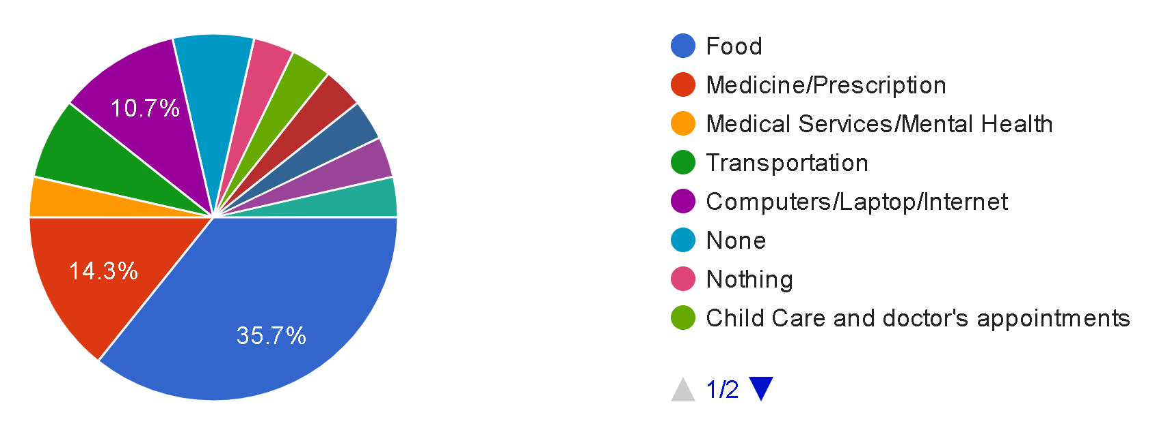 | 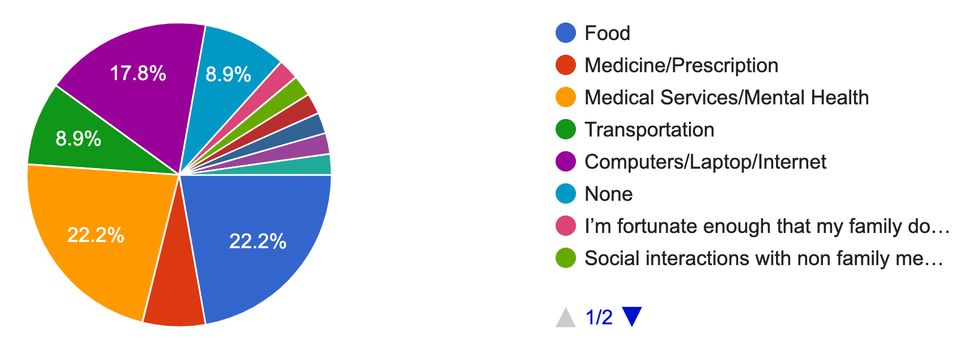
Figure 5. Survey Question: What COVID-19 related resources did you and your family need most?

Homeless Teens Non-Homeless Teens
Figure 6. Survey Question: Do you and your family have access to Personal Protective Equipment (masks, gloves, hand sanitizer, etc)?

Homeless Teens Non-Homeless Teens
Figure 7. Survey Question: Did anyone in your household lose a job since COVID-19?

3.2.2.4 Mental health
Sleep schedule/patterns were significantly more impacted due to the pandemic in the non-homeless teen group (39.3% homeless reported impact vs 75.6% non-homeless reported impact); and 28.9% of the non-homeless teens reported a very unfavorable impact on their sleep (Figure 8). A majority of teens in both groups reported a decrease in interest in usual pleasurable activities (64.3% homeless vs 48.8% non-homeless) (Figure 9). Significantly more non-homeless teens reported feeling depressed/down on themselves (25% homeless vs 66.7% non-homeless), and some indicated feeling this way several times per day (10.7% homeless vs 8.9% non-homeless) (Figure 10). Many teens reported changes in their diet and nutrition during the pandemic (53.6% homeless vs 73.3% non-homeless) (Figure 11). Most teens had access to breakfast/lunch options (89.3% homeless vs 97.8% non-homeless).

Homeless Teens Non-Homeless Teens
Figure 8. Survey Question: How has your sleep schedule been impacted?

Homeless Teens Non-Homeless Teens
Figure 9. Survey Question: How has your interest in usually pleasurable activities been impacted by COVID-19?

Homeless Teens Non-Homeless Teens
Figure 10. Survey Question: Since COVID-19 began, how often have you been feeling down about yourself per week?

Homeless Teens Non-Homeless Teens
Figure 11. Survey Question: How has your diet and nutrition changed since COVID-19?

The aggregate score of the negative impact was 15.07 vs 15.7 respectively. The 2-sample t –test on the aggregate scores of the negative impact of COVID-19 showed no statistical significant difference between the 2 groups - p-value =0.24.

4. Discussion

The study consisted of a set of homeless teenagers ages 12 to 17 and compared them to a set of non-homeless teenagers of a similar age distribution. The majority of the homeless teens were black (64.3%) while the majority of non-homeless teens were white (66.7%). The baseline demographic differences in the two groups is worth noting upfront. A significant portion of teens from homeless families (75%) reported someone in their household had lost their job due to the COVID-19 pandemic compared to only 6.7% of non-homeless teens surveyed. This is likely tied to the social economic disadvantage of the homeless population. A majority of low-income families work in service occupations. According to the U.S Bureau of Labor statistics in July 2020, people employed in service occupations were among the most likely to have been unemployed due to the pandemic. These were due mostly to employer closures or cutbacks due to the pandemic⁷.

The study demonstrates the high impact of the COVID-19 pandemic on teenagers, especially among the homeless youth. The number of non-homeless teenagers who have had a family member contract COVID-19 is far less than in the homeless group - 17.8% versus 32%.

Relating to education and the ability to learn, during the pandemic, many students resorted to on-line learning. Overall, one-third (35.6%) of teens surveyed reported moderate to severe difficulty in learning during the pandemic. Interestingly, homeless teens were 3.7 times more likely to report no impact on learning ability compared to the non-homeless group. Though when reported, the homeless teens were more likely to report more severe negative impacts of the pandemic on their learning. This may be attributable to the recurring theme of “out of the frying pot, into the fire” where adding another dimension to a bad situation, does not make it any more of a bad situation. Homeless teens are so used to a poor learning environment, that the added negative effect that COVID-19 pandemic has is negligible. Non-homeless teens on the other hand, are likely to be more accustomed to a more positive environment, and hence could be more likely to report the negative impact of the pandemic. This difference in perception is more compounded by the observation that while none of the non-homeless teens reported a lack of access to internet and computers, 25% of the homeless youth surveyed described poor or no access to the internet. A self-perception of gaps or disparity in learning in the homeless teens is an inaccurate measure of assessing intellectual and educational well being. An assessment of the impact of the COVID-19 on future outlook would shed further light on the impact on education. More homeless teens who had intended to pursue higher education changed their plans from 92.9% to 78.6%, indicating that more had decided to work after high school instead of going to college. Typical statements made were: "Trying to find work now. I have to put higher education on hold,” and “Need to find work to help family.”

Children experiencing homelessness have been shown to have higher levels of emotional and behavioral problems ^{2,3}. Surprisingly, reverse findings on mental wellbeing reported by teens in the study were observed. The non-homeless group were almost twice as likely to report changes in sleep schedule, with 29% reporting a very unfavorable impact on sleep. Sleep deprivation is strongly linked to mental impairment such as depression and anxiety. Loss of pleasure in activities is also another good indicator of mental unwellness. While 55% of all teens surveyed reported a significant loss of pleasure in activities, the non-homeless teens were almost 3 times more likely to report feeling depressed or down on themselves. This disproportionate impact of the pandemic on the non-homeless teen group poses a paradox. One possible explanation is that similar to the impact on learning, this observation is due to difference in perception of homeless teens, where there is a “you can’t make a bad situation worse” attitude. The non-homeless teens may be used to less social interactions already, so the change from the pandemic is not as noticeable or distinct compared to the non-homeless group. Hence, typical indicators in teens that are in socially advantageous situations may not be as accurate in assessing mental wellbeing indicators in homeless youth.

The shortage of personal protective equipment (PPE) during the initial phase of the COVID-19 pandemic has been well documented. The World Health Organization (WHO) and United Nations Children’s Fund (UNICEF) advise that children aged 12 and over should wear a mask
under the same conditions as adults ⁸. Determining access of the teens to PPE during the pandemic while 100% of the non-homeless teens had access, 10.7% of the homeless teens reported a lack of PPE. Measures are needed to meet the need for adequate PPE of the vulnerable youth in the homeless population.

- Also, as a result of the pandemic, there has been food insecurity and food shortages in certain communities. The U.N. World Food Program has warned that an additional 130 million people could face acute food insecurity by the end of 2020, on top of the 135 million people who were already acutely food insecure before the crisis, because of income and remittance losses⁹. Food was the most common resource needed during the pandemic by all teens and their families in this study, followed by medicines and prescriptions.

5. Conclusion

Our study helps to highlight the impact of the COVID-19 pandemic on teenagers - especially homeless youth in the Fort Bend Family Promise Program. It demonstrates the impact on their mental well being, learning and future outlook. We see a disproportionate negative impact of the pandemic on the homeless youth in accessing self-protective resources, food and employment. This experience might adversely influence the ability of these homeless teens to pursue higher education as they are inclined to want to help support their families.

Preparing for a pandemic is challenging, and mitigating the impact is even more daunting. More awareness and research is required on the impact of COVID-19 especially on homeless teens as well as non-homeless teens. Investment in community programs such as Fort Bend Family Promise and providing additional resources to homeless families is needed to address possible shortages of PPE, food, basic necessities, internet and computers access for education and other resources to mitigate the impact of COVID-19. Homeless and non-homeless teens represent the future and investing in their overall well being would have both short-term impacts during the crisis, and long-term effects on their plans and future outlook.

References

1. Family Promise. Fort Bend Family Promise Program. 2020. https://fortbendfamilypromise.org/about/
2. State of Homelessness: 2020. National Alliance to End Homelessness. 2020. https://endhomelessness.org/homelessness-in-america/homelessness-statistics/state-of-homelessness-2020/
3. Children and Families. National Alliance to End Homelessness. https://endhomelessness.org/homelessness-in-america/who-experiences-homelessness/children-and-families/
4. 2019 Annual Homeless Assessment Report to Congress: Part 1 - PIT Estimates of Homelessness in the U.S. January 2020 (HUD)
https://www.huduser.gov/portal/sites/default/files/pdf/2018-AHAR-Part-1.pdf
5. United States Interagency Council on Homelessness - 2018 Key Federal Terms and Definitions of Homelessness Among Youth (USIC) https://www.usich.gov/resources/uploads/asset_library/Federal-Definitions-of-Youth-Homelessness.pdf
6. Homelessness in America Focus on Families with Children. United States Interagency Council on Homelessness. 2018.(USIC) https://www.usich.gov/resources/uploads/asset_library/Homeslessness_in_America_Families_with_Children.pdf
7. Labor Force Statistics from the Current Population Survey. US Bureau of Labor Statistics. https://www.bls.gov/cps/effects-of-the-coronavirus-covid-19-pandemic.htm
8. Coronavirus disease (COVID-19): Children and masks. World Health Organization. https://www.who.int/news-room/q-a-detail/q-a-children-and-masks-related-to-covid-19
9. Risk of hunger pandemic as coronavirus set to almost double acute hunger by end of 2020.https://insight.wfp.org/covid-19-will-almost-double-people-in-acute-hunger-by-end-of-2020-59df0c4a8072

Acknowledgements

We would like to thank Fort Bend Family Promise for assisting with this study, and especially Vera Johnson (Executive Director), Etta Vincent (Associate Director) and all the staff for the important work that they do each day at Family Promise.

